**Week-3-Mandatory Exercises for Spring Data JPA with Spring Boot, Hibernate**

**Hands on 1**

**Spring Data JPA - Quick Example**   
  
**Software Pre-requisites**

* MySQL Server 8.0
* MySQL Workbench 8
* Eclipse IDE for Enterprise Java Developers 2019-03 R
* Maven 3.6.2

**Create a Eclipse Project using Spring Initializr**

* Go to <https://start.spring.io/>
* Change Group as “com.cognizant”
* Change Artifact Id as “orm-learn”
* In Options > Description enter "Demo project for Spring Data JPA and Hibernate"
* Click on menu and select "Spring Boot DevTools", "Spring Data JPA" and "MySQL Driver"
* Click Generate and download the project as zip
* Extract the zip in root folder to Eclipse Workspace
* Import the project in Eclipse "File > Import > Maven > Existing Maven Projects > Click Browse and select extracted folder > Finish"
* Create a new schema "ormlearn" in MySQL database. Execute the following commands to open MySQL client and create schema.

> mysql -u root -p

mysql> create schema ormlearn;

* In orm-learn Eclipse project, open src/main/resources/application.properties and include the below database and log configuration.

# Spring Framework and application log

logging.level.org.springframework=info

logging.level.com.cognizant=debug

# Hibernate logs for displaying executed SQL, input and output

logging.level.org.hibernate.SQL=trace

logging.level.org.hibernate.type.descriptor.sql=trace

# Log pattern

logging.pattern.console=%d{dd-MM-yy} %d{HH:mm:ss.SSS} %-20.20thread %5p %-25.25logger{25} %25M %4L %m%n

# Database configuration

spring.datasource.driver-class-name=com.mysql.cj.jdbc.Driver

spring.datasource.url=jdbc:mysql://localhost:3306/ormlearn

spring.datasource.username=root

spring.datasource.password=root

# Hibernate configuration

spring.jpa.hibernate.ddl-auto=validate

spring.jpa.properties.hibernate.dialect=org.hibernate.dialect.MySQL5Dialect

* Build the project using ‘mvn clean package -Dhttp.proxyHost=proxy.cognizant.com -Dhttp.proxyPort=6050 -Dhttps.proxyHost=proxy.cognizant.com -Dhttps.proxyPort=6050 -Dhttp.proxyUser=123456’ command in command line
* Include logs for verifying if main() method is called.

import org.slf4j.Logger;

import org.slf4j.LoggerFactory;

private static final Logger LOGGER = LoggerFactory.getLogger(OrmLearnApplication.class);

public static void main(String[] args) {

SpringApplication.run(OrmLearnApplication.class, args);

  LOGGER.info("Inside main");

}

* Execute the OrmLearnApplication and check in log if main method is called.

SME to walk through the following aspects related to the project created:

1. src/main/java - Folder with application code
2. src/main/resources - Folder for application configuration
3. src/test/java - Folder with code for testing the application
4. OrmLearnApplication.java - Walkthrough the main() method.
5. Purpose of @SpringBootApplication annotation
6. pom.xml
   1. Walkthrough all the configuration defined in XML file
   2. Open 'Dependency Hierarchy' and show the dependency tree.

**Country table creation**

* Create a new table country with columns for code and name. For sample, let us insert one country with values 'IN' and 'India' in this table.

create table country(co_code varchar(2) primary key, co_name varchar(50));

* Insert couple of records into the table

insert into country values ('IN', 'India');

insert into country values ('US', 'United States of America');

**Persistence Class - com.cognizant.orm-learn.model.Country**

* Open Eclipse with orm-learn project
* Create new package com.cognizant.orm-learn.model
* Create Country.java, then generate getters, setters and toString() methods.
* Include @Entity and @Table at class level
* Include @Column annotations in each getter method specifying the column name.

import javax.persistence.Column;

import javax.persistence.Entity;

import javax.persistence.Id;

import javax.persistence.Table;

@Entity

@Table(name="country")

public class Country {

  @Id

    @Column(name="code")

    private String code;

    @Column(name="name")

    private String name;

// getters and setters

  // toString()

}

*Notes:*

* @Entity is an indicator to Spring Data JPA that it is an entity class for the application
* @Table helps in defining the mapping database table
* @Id helps is defining the primary key
* @Column helps in defining the mapping table column

**Repository Class - com.cognizant.orm-learn.CountryRepository**

* Create new package com.cognizant.orm-learn.repository
* Create new interface named CountryRepository that extends JpaRepository<Country, String>
* Define @Repository annotation at class level

import org.springframework.data.jpa.repository.JpaRepository;

import org.springframework.stereotype.Repository;

import com.cognizant.ormlearn.model.Country;

@Repository

public interface CountryRepository extends JpaRepository<Country, String> {

}

**Service Class - com.cognizant.orm-learn.service.CountryService**

* Create new package com.cognizant.orm-learn.service
* Create new class CountryService
* Include @Service annotation at class level
* Autowire CountryRepository in CountryService
* Include new method getAllCountries() method that returns a list of countries.
* Include @Transactional annotation for this method
* In getAllCountries() method invoke countryRepository.findAll() method and return the result

**Testing in OrmLearnApplication.java**

* Include a static reference to CountryService in OrmLearnApplication class

private static CountryService countryService;

* Define a test method to get all countries from service.

    private static void testGetAllCountries() {

        LOGGER.info("Start");

        List<Country> countries = countryService.getAllCountries();

        LOGGER.debug("countries={}", countries);

        LOGGER.info("End");

    }

* Modify SpringApplication.run() invocation to set the application context and the CountryService reference from the application context.

        ApplicationContext context = SpringApplication.run(OrmLearnApplication.class, args);

        countryService = context.getBean(CountryService.class);

        testGetAllCountries();

* Execute main method to check if data from ormlearn database is retrieved.

-Final Output:-  
  
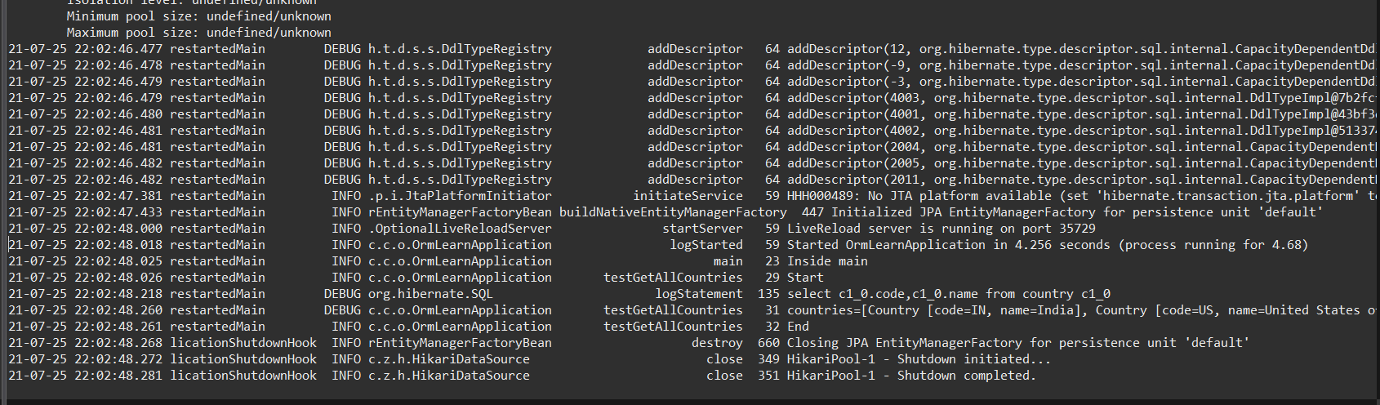

The structure of the project(code is already almost given in the question, so I don’t think I need to share that):  
  
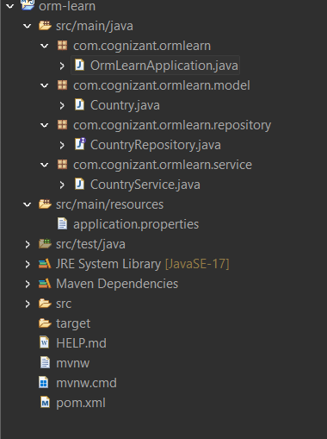

**Hands on 4**

**Difference between JPA, Hibernate and Spring Data JPA**   
  
Java Persistence API (JPA)

* JSR 338 Specification for persisting, reading and managing data from Java objects
* Does not contain concrete implementation of the specification
* Hibernate is one of the implementation of JPA

Hibernate

* ORM Tool that implements JPA

Spring Data JPA

* Does not have JPA implementation, but reduces boiler plate code
* This is another level of abstraction over JPA implementation provider like Hibernate
* Manages transactions

**Refer code snippets below on how the code compares between Hibernate and Spring Data JPA  
Hibernate**

   /* Method to CREATE an employee in the database */

   public Integer addEmployee(Employee employee){

      Session session = factory.openSession();

      Transaction tx = null;

      Integer employeeID = null;

      try {

         tx = session.beginTransaction();

         employeeID = (Integer) session.save(employee);

         tx.commit();

      } catch (HibernateException e) {

         if (tx != null) tx.rollback();

         e.printStackTrace();

      } finally {

         session.close();

      }

      return employeeID;

   }

**Spring Data JPA**  
EmployeeRespository.java

public interface EmployeeRepository extends JpaRepository<Employee, Integer> {

}

EmployeeService.java

@Autowire

  private EmployeeRepository employeeRepository;

@Transactional

public void addEmployee(Employee employee) {

  employeeRepository.save(employee);

  }

​​​​​​​   
  
**Reference Links:**   
<https://dzone.com/articles/what-is-the-difference-between-hibernate-and-sprin-1>   
<https://www.javaworld.com/article/3379043/what-is-jpa-introduction-to-the-java-persistence-api.html>

**Difference Between JPA, Hibernate, and Spring Data JPA**

**Java Persistence API (JPA)**

JPA is a Java specification (defined under JSR 338) that provides a standardized approach for mapping Java objects to relational database tables. It defines a set of interfaces and annotations that enable object-relational mapping but does not provide an actual implementation. JPA is purely an abstraction layer that requires a concrete ORM provider (like Hibernate) to function.

In essence, JPA defines *what* needs to be done for persistence, but not *how* it should be done.

**Hibernate**

Hibernate is a widely-used ORM (Object Relational Mapping) framework that implements the JPA specification. It provides the underlying implementation required to perform the operations defined by JPA. Hibernate manages the low-level details of database communication, such as opening sessions, managing transactions, and executing queries.

When working directly with Hibernate (without Spring), developers must manually handle aspects like session management, exception handling, and transaction boundaries. This leads to more verbose and error-prone code.

**Spring Data JPA**

Spring Data JPA is a part of the Spring ecosystem that provides a higher level of abstraction over JPA and Hibernate. It simplifies the development of repository-based data access layers by eliminating the need for boilerplate code. By extending interfaces such as JpaRepository, developers can perform common CRUD operations without explicitly writing SQL or JPQL queries.

Spring Data JPA also manages transactions automatically and integrates seamlessly with the rest of the Spring framework, promoting cleaner and more maintainable code.

| **Feature** | **JPA** | **Hibernate** | **Spring Data JPA** |
| --- | --- | --- | --- |
| Type | Specification | JPA implementation | Abstraction over JPA/Hibernate |
| Session and Transaction | Not provided | Manually managed | Automatically managed |
| Boilerplate Code | Minimal | Extensive | Very minimal |
| Complexity | Moderate | High | Low |
| Purpose | Defines persistence contract | Provides concrete functionality | Simplifies persistence development |

**Conclusion**

JPA provides a standard for object-relational mapping in Java applications. Hibernate is one of the most popular implementations of this standard and offers robust ORM capabilities. Spring Data JPA builds upon these technologies to offer a simplified and declarative approach to database interaction, reducing development effort and increasing code maintainability.